**Summary of pre-existing public engagement**

**‘What matters to Sheffielders for a good life?’**

**Introduction**

This document summarises the findings within pre-existing sources of public engagement that are relevant to the development of the 2024-2034 Joint Local Health and Wellbeing Strategy (JLHWBS).

**Review question**

The focus for this review is data that informs the following question: ‘What matters to Sheffielders for a good life?’

**Data sources**

Pre-existing sources of public engagement that contained relevant data were identified by members of the Joint Local Health and Wellbeing Strategy Editorial Group – by identifying sources they were already aware of and by reaching out to Health and Wellbeing Board (HWBB) member organisations for any other relevant material.

In total, 22 sources of insight were reviewed and are summarised in Table 1. These sources were published between 2018 and 2023 and included the voices of at least 1836 people living in Sheffield. Not all the sources provided details about the participants, however detail that was shared indicates that these include the voices of younger people, adults of working age, older people, people with learning and physical disabilities, families with children with special educational needs, and people from ethnic minority groups. The sources used a range of methods to gather insights including focus group discussions, surveys with closed or open questions, 1-1 interviews and a creative arts-based approaches. The sources focused on a range of different topics and questions, but all contained some relevant information concerning what matters to Sheffielders for a good life.

*Table 1: Sources of relevant, pre-existing sources of public engagement*

|  |  |  |  |  |
| --- | --- | --- | --- | --- |
| **Source** | **Year** | **Whose voices?** | **How was insight gathered?** | **Focus of the work** |
| **Healthwatch ‘Health and Wellbeing Board Engagement’** | 2018 | Heard from 93 people  Younger people and families, older people, people with learning and physical disabilities, and BAME groups | Used a mix of 1:1 and group sessions, in-depth conversations and brief feedback | What matters to people for health |
| **Youth Cabinet Consultation** | 2022 | 397 respondents    Young people in Year 7 to Y13 | Survey with closed questions | Mental health and wellbeing |
| **Source** | **Year** | **Whose voices?** | **How was insight gathered?** | **Focus of the work** |
| **Youth Cabinet reforming curriculum consultation** | 2022 | 241 respondents  Young people – ages not specified | Survey with open and closed questions | Curriculum at school/college |
| **City Goals consultation in youth clubs** | 2023 | 40 respondents from 6 youth clubs across Sheffield  Young people aged 11-16 | Focus group discussions | Not specified |
| **Park and Arbourthorne Youth Provision Consultation** | 2023 | 207 respondents  Young people, ages not specified | Focus group discussions | Not specified |
| **SEND youth club consultation** | 2023 | 8 participants  Aged 14-24  Accessing SEND Youth Club provision | Arts based and focus group discussion | Friendship |
| **State of Sheffield 2023 - The views of parents of children and young people (aged 0-25 years) with special educational needs and/or disabilities** | 2023 | 496 respondents  Parents of children and young people (aged 0-25 years) with special educational needs and/or disabilities (SEND) in Sheffield. | Survey with closed and open questions | How caring for a child with SEND affects the whole family |
| **SYICS Developing NHS South Yorkshire’s Integrated Care Strategy: the patient and public perspective in Sheffield** | 2023 | Review of existing insight of patient experience and engagement carried out by ICP partners – 102 documents  91 participants | Survey with open questions | What matters to people about their health and wellbeing |
| **Collaborative Conversations – Pitsmoor Adventure Playground** | 2023 | 42 people  Children, young people, and adults of working age | Informal conversations | What is good about the community and what would make Sheffield a better place to grow up, lead a good life and grow old? |
| **Collaborative Conversations - Women and girls in the woods** | 2023 | 13 people  Adult women and girls | Group discussion | How do the women and girls feel alone in nature now and imaging how they may feel in the future. |
| **Source** | **Year** | **Whose voices?** | **How was insight gathered?** | **Focus of the work** |
| **Collaborative Conversations - SAVTE** | 2023 | Not specified | Not specified | Aspirations for Sheffield as a city and what would make your life better. |
| **Collaborative Conversations – Life after crisis** | 2023 | Not specified | Not specified | Not specified |
| **Collaborative Conversations – DWB** | 2023 | 27 people | Group discussion | Role as carers and how mental health services can be improved |
| **Collaborative conversations - Darnal Primary Care** | 2023 | 15 people | Group discussion | Role as carers and how mental health services can be improved |
| **Collaborative Conversations – Bens Centre** | 2023 | 20 people | Individual or group discussions | Aspirations for Sheffield as a city and what would make your life better. |
| **Collaborative Conversations – B:Friend** | 2023 | 12 people  Older people | Group discussion | What has mattered to  people in Sheffield in the past, what concerns them, what they love and what they want for the future. |
| **Collaborative Conversations - Third Angel** | 2023 | 19 people | Group discussion | Aspirations for Sheffield as a city and what would make your life better. |
| **Collaborative Conversations - Disability Sheffield** | 2023 | Not specified | Written contributions and arts-based approach | Not specified |
| **Collaborative Conversations – The Terminus** | 2023 | Not specified | Group discussion | Aspirations for Sheffield in the future |
| **Collaborative Conversations – Family Voice** | 2023 | Women | Group discussion and arts-based approach | Aspirations for Sheffield as a city and what would make your life better. |
| **Collaborative Conversations – Ignite Imaginations** | 2023 | 100 people  People in the Moor Market | Arts-based approaches | What would make Sheffield a better place and what local people need and want. |
| **Collaborative Conversations – The Furnival** | 2023 | 15 people  Women from minority ethnic groups | Arts-based approach and group discussion | Aspirations for Sheffield as a city and what would make your life better. |

**Analysis**

Thematic analysis of the data was undertaken to look for patterns and to find themes. This involved reading through all the sources, undertaking line by line coding and adding new codes to the 'bank' of codes as required, organising codes into descriptive themes according to their similarities or differences and using new codes to capture the group of original codes, generating broad analytical themes. The output of this analysis is seen in Figure 1 and Table 2.

*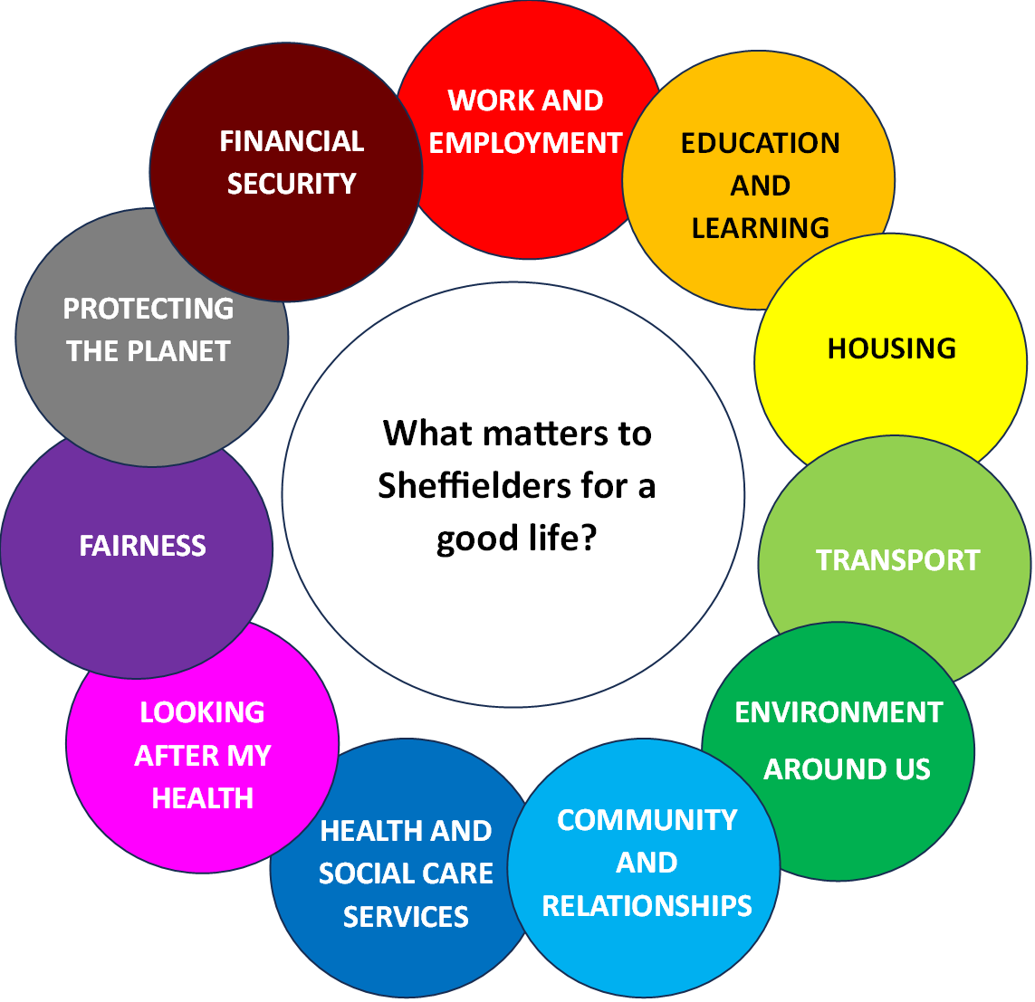Figure 1: The 11 broad areas that matter to Sheffielders for a good life*

*Table 2: Summary of the findings within the 11 broad areas that matters to Sheffielders for a good life*

|  |  |  |
| --- | --- | --- |
| **What matters to Sheffielders for a good life?** | | **Relevant quotes – Sheffielders want…** |
| **Financial security** | Having enough income | *To have enough money to pay my bills and keep out of debt.* |
| Freedom from poverty |
| Freedom from debt |
| Access to sufficient welfare benefits |
| **Work and employment** | Fair wages | *A good job I enjoy.*  *Meaningful work that enhances my wellbeing.*  *To be treated well at work and receive a fair wage for what I do.* |
| Job security |
| Work that is meaningful |
| Opportunities to progress |
| Safe and healthy work environments |
| **Education and learning** | High quality nursery and early years provision | *Education that is focussed on holistic needs.*  *More English classes.*  *A good school that is suitable for my child with special educational needs.* |
| Good schools with great teachers and inspiring curriculums |
| Adult learning opportunities |
| Support and provision for children and adults with additional needs |
| **Housing** | Enough space for the household | *To be able to heat my home.*  *A house that I own.* |
| A quality home that is affordable |
| A home that is warm, safe and secure |
| Possibility of home ownership |
| **Transport** | Regular, reliable and affordable public transport | *More cycle routes everywhere and traffic free areas.*  *More accessible and cheaper public transport.*  *More speed bumps and zebra crossings on roads.* |
| Safe roads |
| Infrastructure that enables active travel |
| **Environment around us** | Access to nature, wildlife and green space | *Easier access to healthy, low-cost foods.*  *Access to fitness classes that suit me.*  *Clean air.*  *More activities for Young People that are free or cheap.* |
| Clean air and clean spaces |
| Facilities for people of all ages, for leisure, socialising and being active |
| Access to affordable healthy food |
| Access to WiFi |
| **Community and relationships** | Close, caring relationships and people to rely on | *Have people around me that I can trust and who listen to me and treat me with kindness, people around me who I can rely on.*  *To feel safer because sometimes it's scary where I live.*  *More kindness for others – to feel responsible and caring for others in their community.*  *More festivals to bring people closer together.*  *More understanding of diversity, more mixed communities instead of them vs us - be as one.*  *The council and other people of power listen.* |
| Safe, well policed, and crime-free neighbourhood |
| Opportunities for participation |
| Celebrating our culture and heritage |
| Cohesion and neighbourliness |
| Active voluntary, community, and faith groups |
| **Health and Social Care services** | Availability of services | *Be in control of decisions about my own care and needs - and be respected and listened to… we all deserve to be treated with warmth, understanding, kindness, and non-patronising care. And without prejudice, and second guessing.*  *Have the right access to services when needed and for those working within services to be compassionate and have sufficient time to listen.*  *The reassurance that good social care will be available if needed.* |
| Awareness of services |
| Accessibility of services |
| Services that support me to manage my own care |
| Quality, safety and being treated with kindness and compassion |
| Focussing on both prevention and treatment of disease and ill health |
| **Looking after my health** | Eating well | *To play football in the park*  *More chance to be creative.*  *Be a healthy weight…eat healthy foods*  *Have good fitness, a strong heart…don’t smoke…don’t drink too much.* |
| Being creative |
| Giving and volunteering |
| Being physically active |
| If/how I use substances |
| Continually learning |
| Quality sleep |
| Sexual behaviours |
| Manageable caring responsibilities |
| **Fairness** | Opportunities for everyone in our society | *Be able to access good quality care when it is needed; that all sectors of the community feel they can do the same.*  *To live in an equal society…I want to live in a city that takes care of the most vulnerable, and where everyone is valued.*  *No racism in the area. All neighbourhoods are supported and treated fairly* |
| Leaving no one behind |
| Freedom from racism and discrimination |
| **Protecting the planet** | Reducing air pollution | *A green city with a low carbon footprint.* |
| Recycling and reducing waste |

**Confidence in the findings**

Confidence in the findings was assessed using the [CERQual framework](https://www.cerqual.org/what-is-the-grade-cerqual-approach2/), which involved looking at the data contributing to each finding and assessing relevance, adequacy (number of sources and richness of the data), and coherence (evidence of conflicting findings). As there was such limited information about the methods adopted in the reports, methodological limitations, whilst part of the CERQual framework, was not considered here. A summary of the CERQual assessment can be seen in Table 3.

Of the 51 findings, there is high confidence in 28, moderate confidence in 8 and low confidence in 15. Low confidence primarily resulted from concerns about adequacy of data supporting the findings. Broad themes with no low confidence findings were Transport, Education and Learning, Community and Relationships, and Fairness. The broad themes with the greatest proportion of low confidence findings are Work and employment, Housing, Looking after my health, and Protecting the planet.

*Table 3: Assessment of confidence in the findings*

|  |  |  |  |  |  |
| --- | --- | --- | --- | --- | --- |
| **Finding** | | **Confidence rating** | **CERQual component assessment** | | |
| **Concerns about adequacy** | **Concerns about relevance** | **Concerns about coherence** |
| **Financial security** | Having enough income | **High** | **minor** | **minor - some reports focussed on other topics** | **none** |
| Freedom from poverty | **High** | **minor** | **none** | **none** |
| Freedom from debt | **low** | **serious** | **none** | **none** |
| Access to sufficient welfare benefits | **moderate** | **moderate** | **minor - some reports focussed on other topics** | **none** |
| **Work and employment** | Fair wages | **moderate** | **minor** | **none** | **none** |
| Job security | **low** | **serious** | **none** | **none** |
| Work that is meaningful | **high** | **none** | **none** | **none** |
| Opportunities to progress | **low** | **serious** | **none** | **none** |
| Safe and healthy work environments | **low** | **serious** | **none** | **none** |
| **Education and learning** | Access to high quality nursery and early years provision | **moderate** | **moderate** | **minor - some reports focussed on other topics** | **none** |
| Access to good schools with great teachers and inspiring curriculums | **high** | **minor** | **minor - some reports focussed on other topics** | **none** |
| Adult learning opportunities | **high** | **minor** | **none** | **none** |
| Support and provision for children and adults with additional needs | **high** | **minor** | **minor - some reports focussed on other topics** | **none** |
| **Housing** | Enough space for the household | **low** | **serious** | **none** | **none** |
| A quality home that is affordable | **high** | **minor** | **none** | **none** |
| A home that is warm, safe and secure | **high** | **minor** | **none** | **none** |
| Possibility of home ownership | **low** | **serious** | **none** | **none** |
| **Transport** | Regular, reliable and affordable public transport | **high** | **none** | **minor - some reports focussed on other topics** | **none** |
| Safe roads | **high** | **none** | **minor - some reports focussed on other topics** | **none** |
| Infrastructure that enables active travel | **high** | **none** | **minor - some reports focussed on other topics** | **none** |
| **Environment around us** | Access to nature, wildlife and green space | **high** | **none** | **minor - some reports focussed on other topics** | **none** |
| Clean air and clean spaces | **high** | **none** | **minor - some reports focussed on other topics** | **none** |
| Facilities for people of all ages, for leisure, socialising and being active | **high** | **none** | **minor - some reports focussed on other topics** | **none** |
| Access to affordable healthy food | **low** | **moderate** | **minor - some reports focussed on other topics** | **none** |
| Access to WiFi | **low** | **serious** | **none** | **none** |
| **Community and relationships** | Close, caring relationships and people to rely on | **high** | **none** | **minor - some reports focussed on other topics** | **none** |
| Safe, well policed, and crime-free neighbourhood | **high** | **none** | **minor - some reports focussed on other topics** | **none** |
| Opportunities for participation | **high** | **minor** | **none** | **none** |
| Celebrating our culture and heritage | **moderate** | **minor** | **none** | **none** |
| Cohesion and neighbourliness | **high** | **none** | **minor - some reports focussed on other topics** | **none** |
| Active voluntary, community, and faith groups | **high** | **none** | **minor - some reports focussed on other topics** | **none** |
| **Health and social care services** | Availability of services | **high** | **none** | **none** | **none** |
| Awareness of services | **low** | **serious** | **none** | **none** |
| Accessibility of services | **high** | **none** | **minor - some reports focussed on other topics** | **none** |
| Services that support me to manage my own care | **low** | **serious** | **none** | **none** |
| Quality, safety and being treated with kindness and compassion | **high** | **minor** | **minor - some reports focussed on other topics** | **none** |
| Focussing on prevention and treatment of disease and ill health | **moderate** | **moderate** | **none** | **none** |
| **Looking after my health** | Eating well | **High** | **none** | **none** | **none** |
| Being creative | **moderate** | **moderate** | **none** | **none** |
| Giving and volunteering | **low** | **serious** | **none** | **none** |
| Being physically active | **High** | **minor** | **minor - some reports focussed on other topics** | **none** |
| If/how I use substances | **moderate** | **moderate** | **minor - some reports focussed on other topics** | **none** |
| Continually learning | **low** | **serious** | **none** | **none** |
| Quality sleep | **low** | **serious** | **none** | **none** |
| Sexual behaviours | **low** | **serious** | **none** | **none** |
| Manageable caring responsibilities | **moderate** | **minor** | **none** | **none** |
| **Fairness** | Opportunities for everyone in our society | **high** | **none** | **none** | **none** |
| Leaving no one behind | **High** | **minor** | **none** | **none** |
| Freedom from racism and discrimination | **High** | **none** | **minor - some reports focussed on other topics** | **none** |
| **Protecting the planet** | Reducing air pollution | **High** | **none** | **none** | **none** |
| Recycling and reducing waste | **low** | **serious** | **none** | **none** |