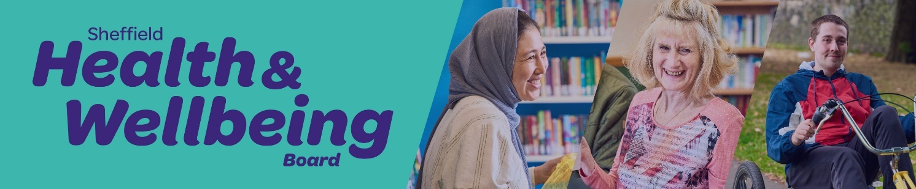

**Summary of the Fair and Healthy Sheffield Plan**

It’s very clear from our [Sheffield City Goals](https://files.cargocollective.com/c459292/SCG_two-pager_FINAL.pdf) that fairness and health really matter to us as a city. One of our goals says we want to ‘shape our city around fairness, wellbeing and combating poverty.’

Right now, things are not fair. Some people in Sheffield die younger and have worse health than others. That includes people living in poverty, those with disabilities, people with serious mental illnesses, people from some ethnic minority groups, people experiencing homelessness and people who are seeking asylum or are refugees.

These differences don't happen by accident. They happen because of the conditions we’re born into and that we live in. This includes facing racism and discrimination, living in poverty, not getting a good education, having low-paying and insecure jobs, living in poor housing, the quality of food we can access, the support we get from family and friends, the state of our local area, and how easy it is to access health and social care. Global warming also affects our lives.

We know it doesn’t have to be this way, and there are things we can do to create a different future.

**The aim of the plan is to close the unfair gaps in length and quality of life by improving the health and wellbeing of those worst off the fastest.**

**What’s in the plan?**

The [Fair and Heathy Sheffield plan](https://health-wellbeing.sheffield.gov.uk/fair-healthy-sheffield-plan) is made up of eight building blocks and four radical shifts.

[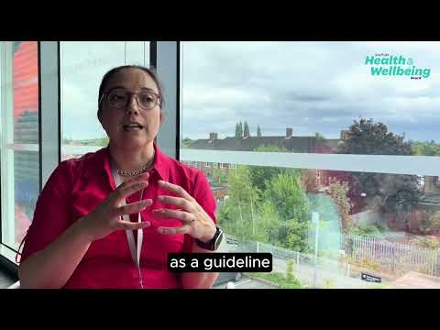](https://www.youtube.com/embed/4MeKuQyg6tQ?feature=oembed)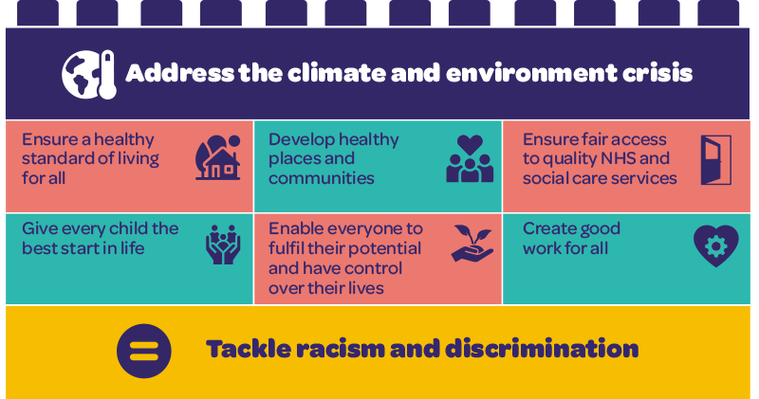The eight [building blocks](https://health-wellbeing.sheffield.gov.uk/building-blocks) are the foundations for a fairer and healthier future for everyone in Sheffield. This is where we need to focus our efforts to close the unfair gaps in length and quality of life. They include tackling racism and discrimination, giving every child a good start in life, ensuring everyone has a decent standard of living, helping people to reach their full potential and have control over their lives, providing good work for all, developing healthy places and communities, ensuring fair access to health and social care services, and addressing the climate and environmental crisis.

The building blocks explained

Investing in these building blocks will help us to create more good health for everyone, from the very youngest to the very oldest. They’re about making sure that everyone has what they need to live their best life. Within each building block we have identified important areas that we need to focus on first as a whole city.

The four [radical shifts](https://health-wellbeing.sheffield.gov.uk/radical-shifts) describe how we need to do things differently to make Sheffield fairer and heathier. A radical shift means doing things in a new and important way. These changes can't just be for show – they must be real and deep. These big changes will take time and lots of smaller steps. They might feel hard or scary or too difficult. But if we want these changes to happen, we need to be brave, try new things and learn from our mistakes. We will need to help each other and keep going, without giving up.

These radical shifts are: Leadership and workforce, Partnerships and collaboration, Resources, and Monitoring and accountability.

[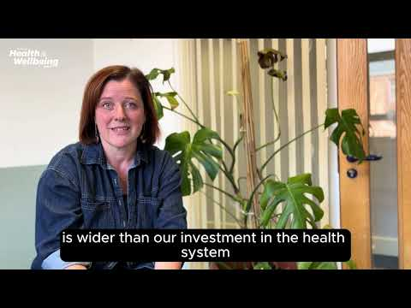](https://www.youtube.com/embed/p0HGxpsLQnE?feature=oembed)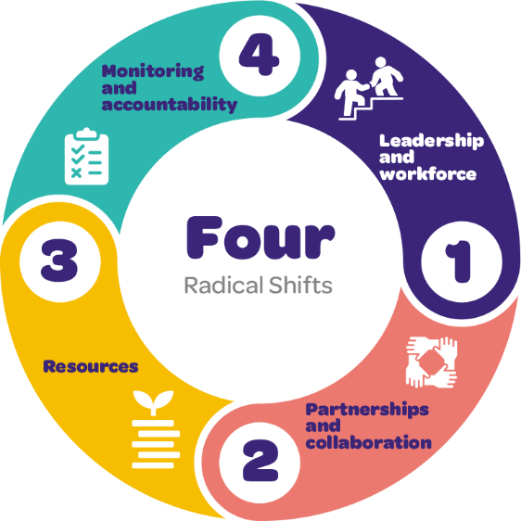

The radical shifts explained

**How are we going to make it happen?**

Making this plan work needs everyone in Sheffield to come together, do their part and take [action](https://health-wellbeing.sheffield.gov.uk/action). No single group or organisation can do it alone. We need partnership groups across the city, the Council, the NHS, the Universities, the Voluntary, Community, Faith, and Social Enterprise sectors, businesses of all sizes, and local communities to get involved.

This is a big job, and it will take time, so the plan will last for 10 years from 2024 to 2034. We will regularly check our progress and the [impact](https://health-wellbeing.sheffield.gov.uk/impact) we’re having to make sure we’re on the right path. Every three years the Health and Wellbeing Board will also review where we need to focus our efforts within this plan.

**What the Health and Wellbeing Board is going to do**

The Health and Wellbeing Board has a yearly plan that explains what we will do to make Sheffield fairer and healthier. This plan focuses on the areas where the Board can make the biggest difference. This year the Board is focussing on delivering our commitments to the four radical shifts and five priority areas within the building blocks:

1. Build strong relationships and a sense of belonging in communities, and empower people to work together and take action
2. Provide good working conditions for everyone
3. Listen to and involve groups of people who have the most difficulty accessing NHS and Social Care services
4. Make sure everyone has a decent, affordable home
5. Plan NHS and Social Care services and develop the workforce to meet current and future needs

Board members are also taking the new Plan to their organisations and sectors to identify what more they can do to contribute to the building blocks and the radical shifts, and making public commitments about their role in driving this work forward.

**What organisations and businesses can do:**

* Decide if you want to be part of this city-wide mission for a fairer and healthier Sheffield
* Look at the building blocks and radical shifts to see where you are already contributing and where you could do more.
* Challenge yourself to think about how you can contribute – as an employer, a purchaser of good and services, a provider of goods and services, an owner of land and other assets, a producer of waste, and by working in partnership with other organisations and with communities
* Make some public commitments to action and be accountable for delivering on these promises

**What people who live in Sheffield can do:**

* Talk about this plan with your friends, family, neighbours, and co-workers so that more people in Sheffield know about it.
* Get more involved in your local community – support your neighbours, join a group or activity, work with others to make changes where you live and call for action from organisations in the city like the council or the NHS or businesses
* Explore ways you could volunteer
* Encourage your employer to get involved in making this plan happen
* Talk to your local councillor about the changes you want to see in your community and the city
* Come to Health and Wellbeing Board [meetings and events](https://health-wellbeing.sheffield.gov.uk/events-sheffield-health-wellbeing-board) and share your views
* [Get in touch](https://health-wellbeing.sheffield.gov.uk/contact) with us directly with your thoughts and ideas

**Find out more**

You can find out more about the Fair and Healthy Sheffield Plan on the [Health and Wellbeing Board website](https://health-wellbeing.sheffield.gov.uk/fair-healthy-sheffield-plan).

You can sign up to receive updates from the Board [here.](https://public.govdelivery.com/accounts/UKSHEFFIELD/signup/36972)